**ACTION LINK DOCUMENTATION**

SUMMARY:

***HERE WE ARE GOING TO CREATE PAYABLE INVOICE AND IMPORT SUPPLIER ANALYSIS .IN PAYABLE ANALYSIS WE HAVE SUPPLIER NAME AND DETAILED INFORMATION ABOUT SUPPLIER IS IN SUPPLIER ANALYSIS.OUR AIM:-WHEN WE CLICK SUPPLIER NAME IN PAYABLE ANALYSIS WE HAVE TO NAVIGATE TO SUPPLIER ANALYSIS WHERE WE HAVE OUR SUPPLIER DETAILS(WANT TO GET DETAIL INFORMATION ABOUT THAT PARTICULAR SUPPLIER.)***

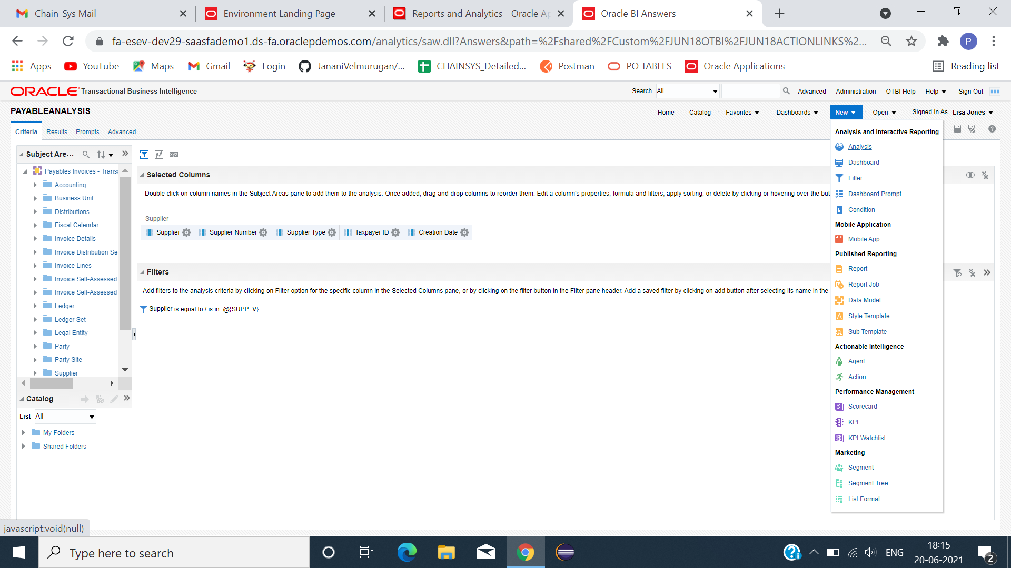

**PAYABLE ANALYSIS**

*CLICK NEW -> ANALYSIS ->SUBJECT AREA (PAYABLE INVOICE)-> SELECT COLUMN -> SAVE.

*CLICK RESULT(TO VIEW DATA)->CREATE CHART(AS WE NEED WITH OUR MEASURES).

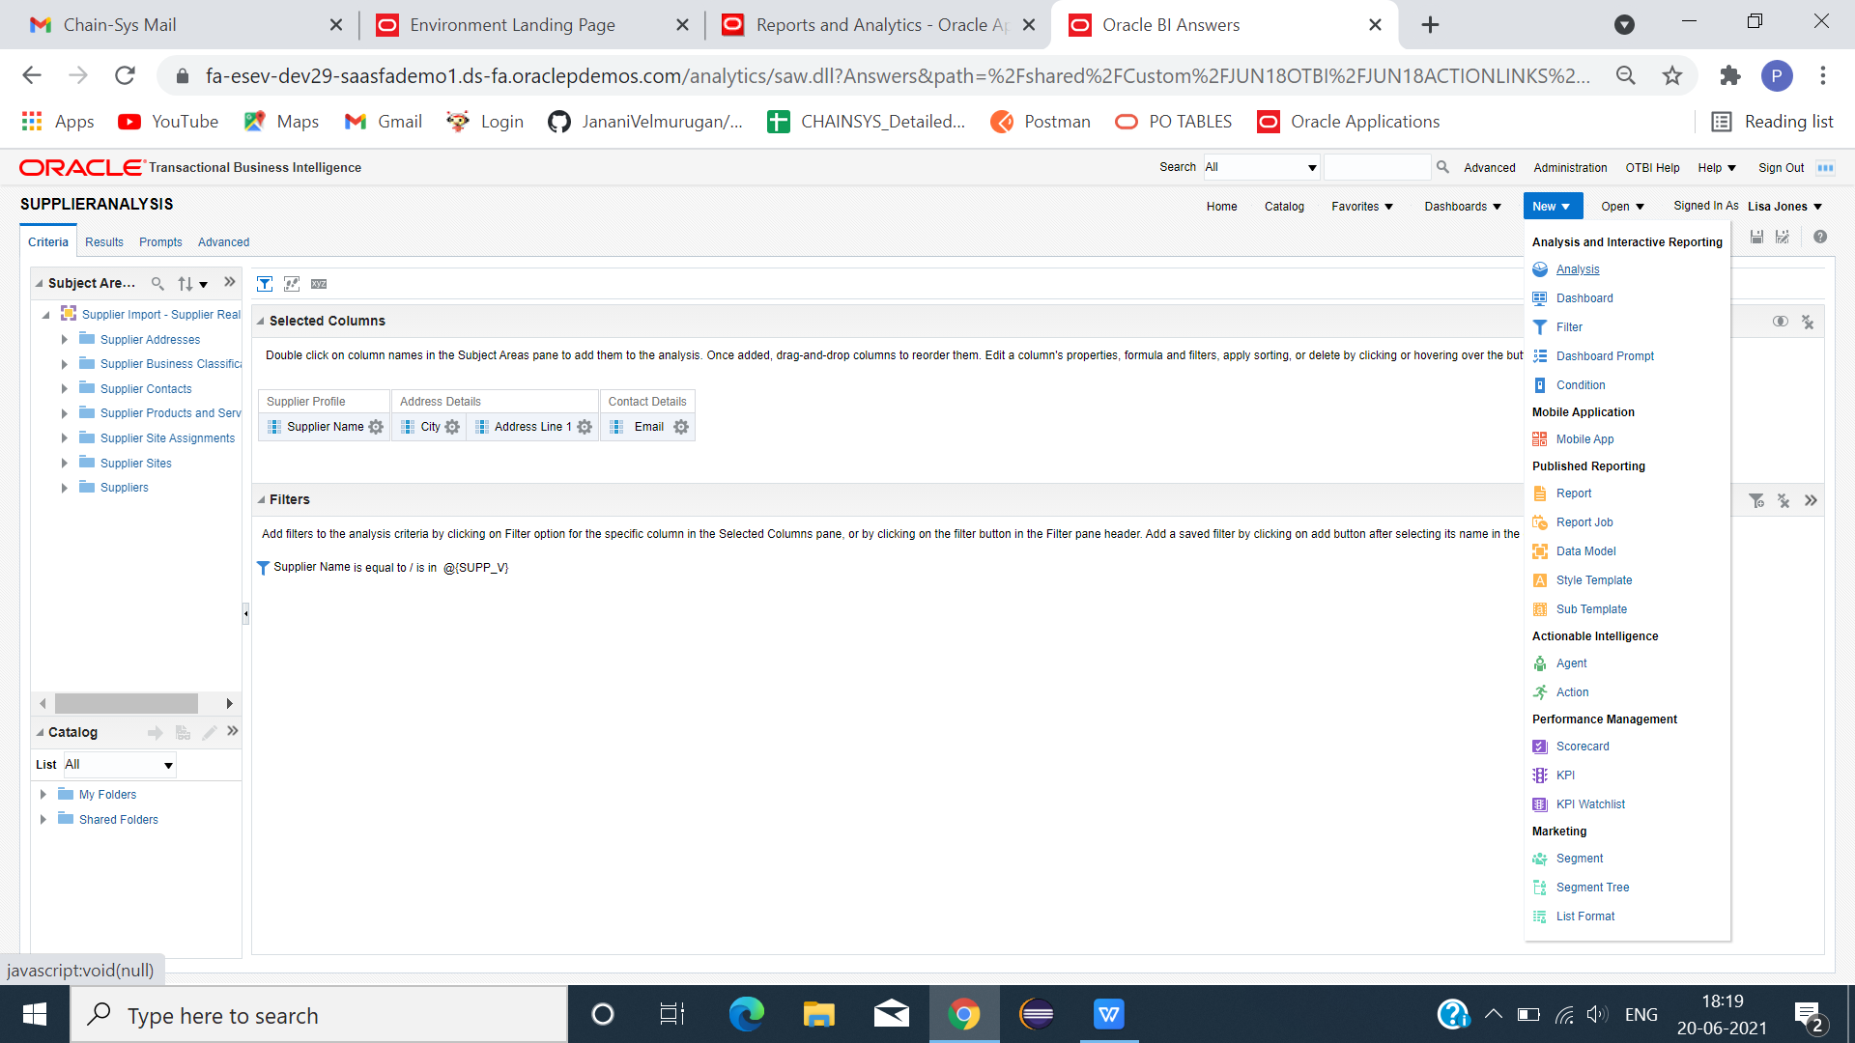

**SUPPLIER ANALYSIS**

*CLICK NEW -> ANALYSIS ->SUBJECT AREA(IMPORT SUPPLIER REAL TIME) -> SELECT COLUMN -> SAVE.

*CLICK RESULT(TO VIEW DATA)->CREATE CHART(AS WE NEED WITH OUR MEASURES).

**DASHBOARD PROMPT**

*CLICK -> NEW -> DASHBOARD PROMPT.

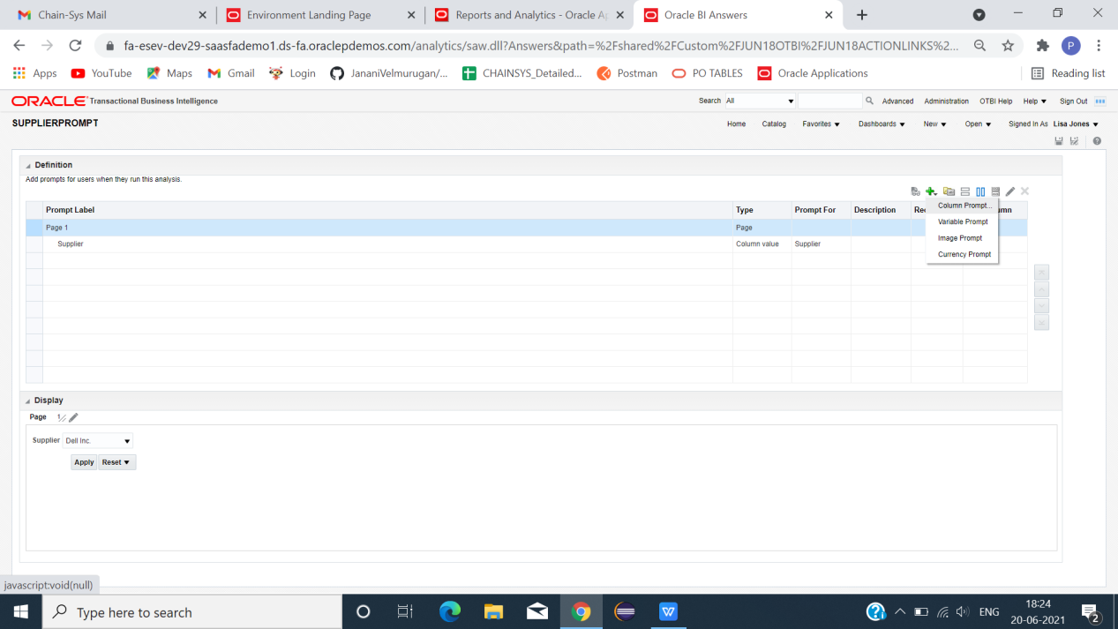

*CLICK +ICON -> COLUMN PROMPT -> SELECT SUPPLIER(IN PAYABLE INVOICE).

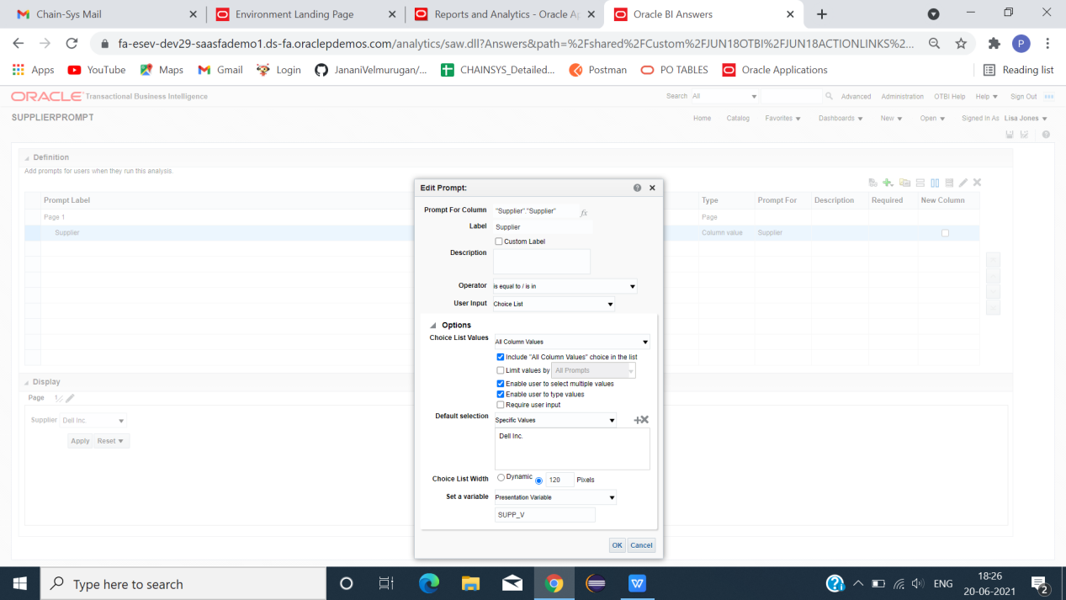

*ENABLE -> INCLUDE ALL COLUMN VALUES -> DEFAULT SELECTION -> +ICON(SELECT COLUMN TO DEFAULT DISPLAY)-> SET A VARIABLE ->( PRESENTATION VARIABLE) -> GIVE VARIABLE NAME->OK.

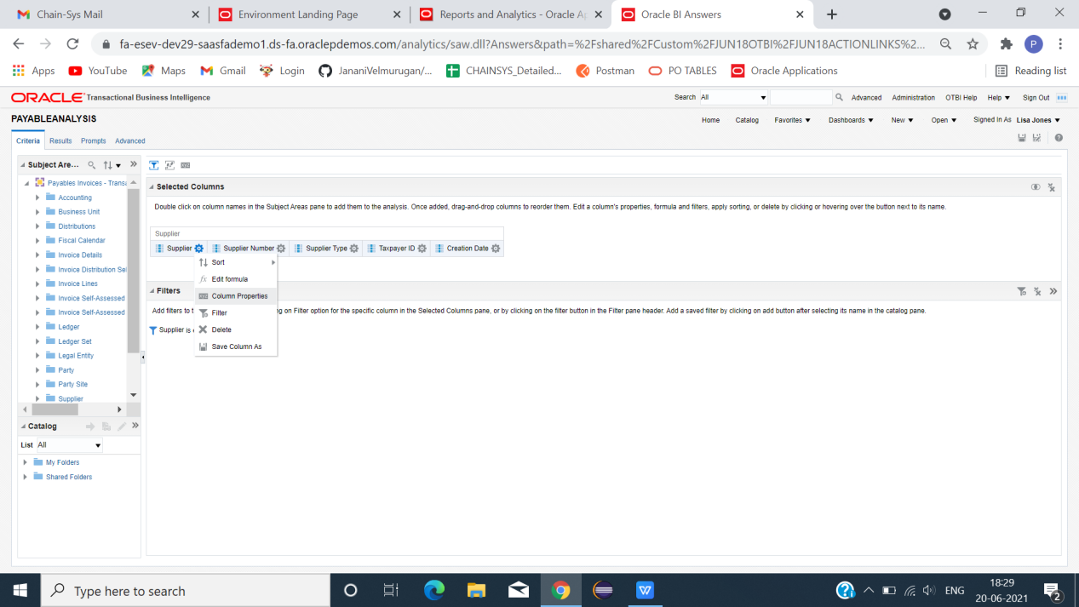

*GO TO PAYABLE ANALYSIS -> CRITERIA -> SUPPLIER -> COLUMN PROPERTIES ->INTERACTION.

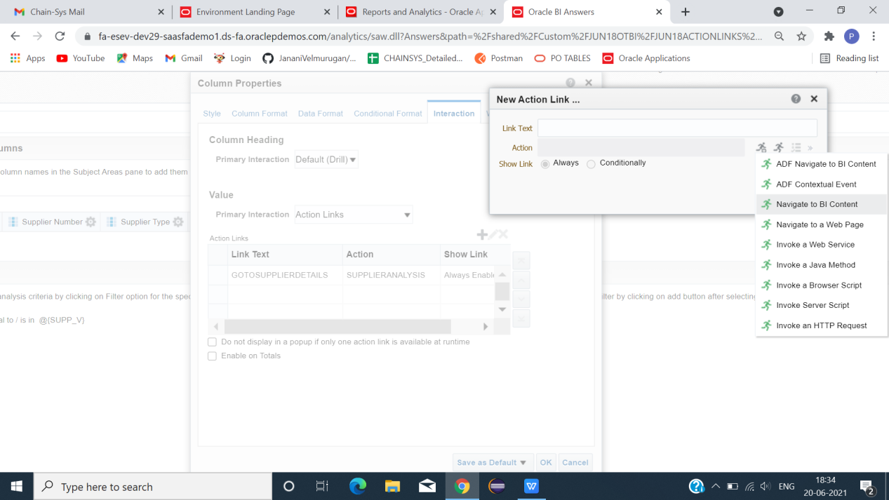

*VALUE -> PRIMARY INTERACTION -> ACTION LINK -> +ICON(ADD ACTION LINK)-> LINK TEXT(NAME)-> ACTION -> CREATE ACTION LINK ICON(+)->NAVIGATE TO BI CONTENT (SHARED FOLDER -> SELECT SUPPLIER ANALYSIS)-> OK -> OK.

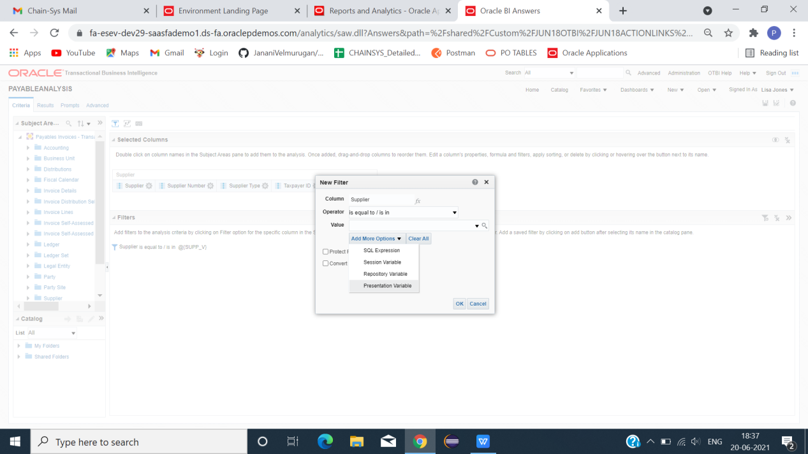

*CLICK FILTER ICON -> COLUMN -> SUPPLIER->ADD MORE OPTION -> PRESENTATION VARIABLE.

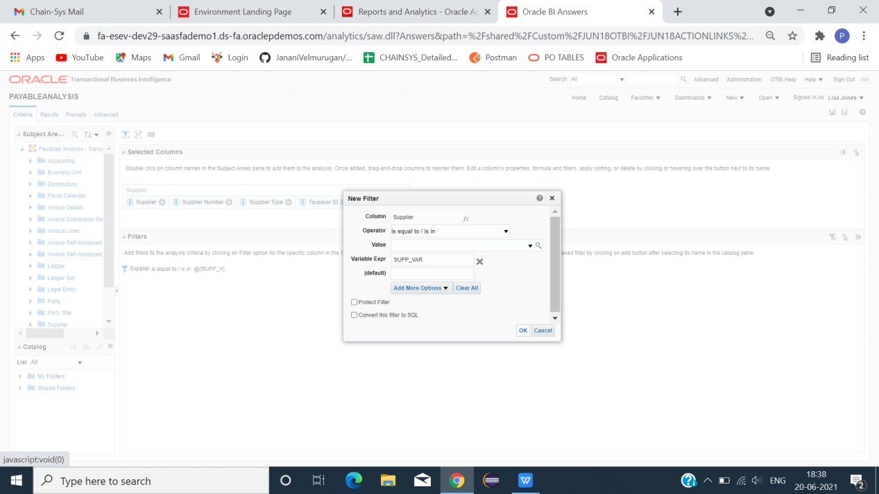

*VARIABLE EXPR(COPY NAME WE CREATED FOR PRESENTATION VARIABLE)->OK.

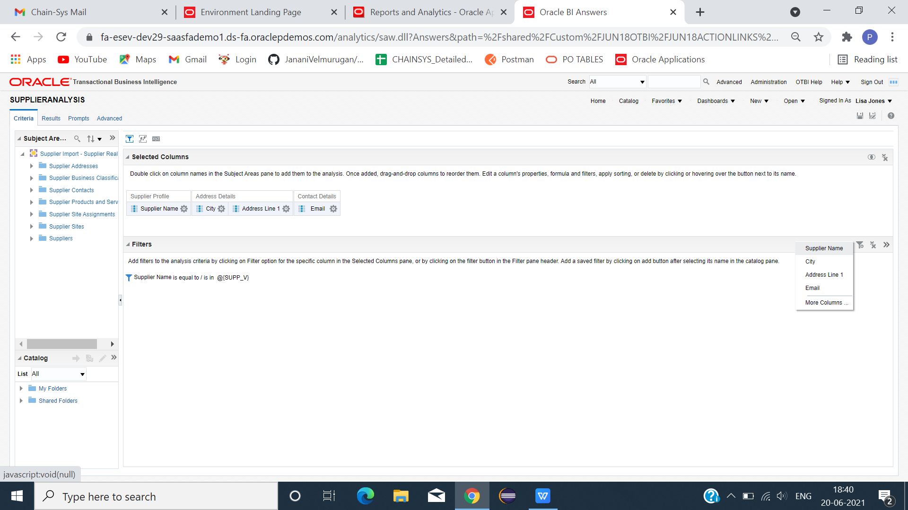

*GO TO SUPPLIER ANALYSIS -> FILTER -> SUPPLIER NAME -> ADD MORE OPTION ->PRESENTATION VARIABLE ->VARIABLE EXPR (PRESENTATION VAR NAME)->OK.

**CREATE DASHBOARD**

*CLICK -> NEW -> DASHBOARD.

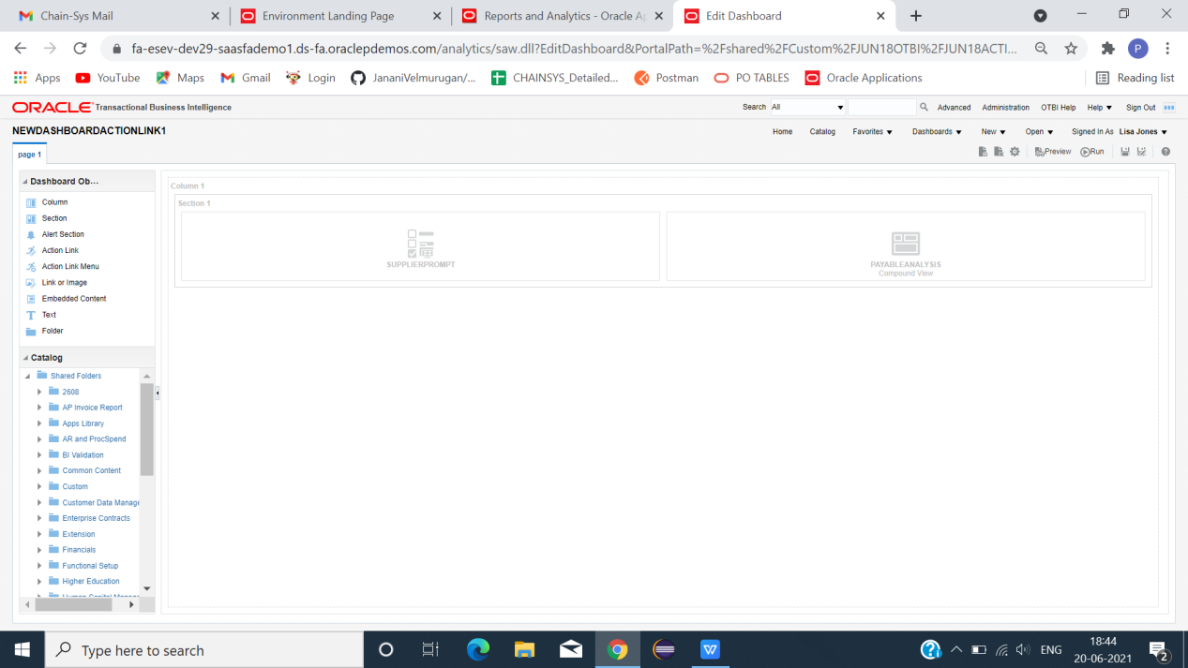

*DRAG PAYABLE(SUPPLIER) PROMPT -> PAYABLE ANALYSIS -> SAVE -> RUN.

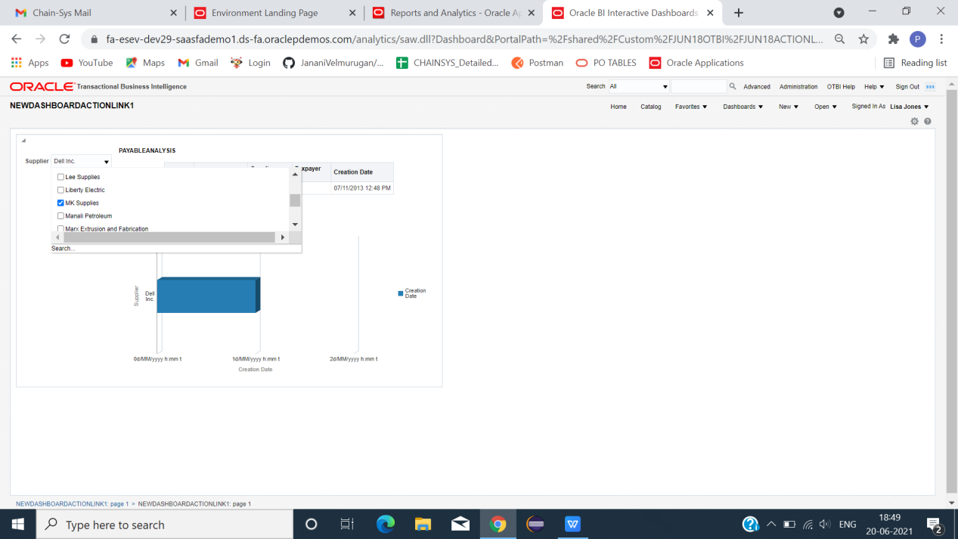

*SELECT SUPPLIER.

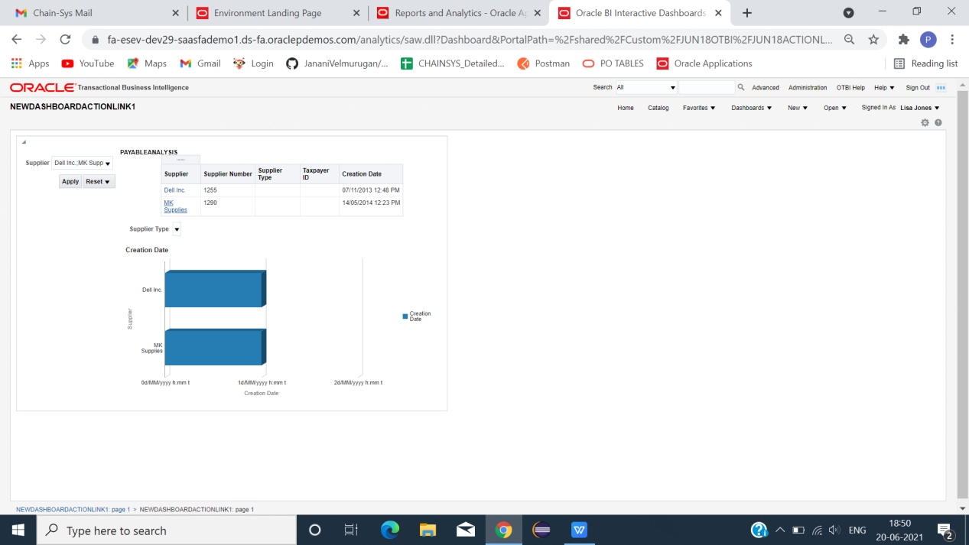

*CLICK SUPPLIER WE APPLY.(IT WILL NAVIGATE TO SUPPLIER ANALYSIS(SUPPLIER DETAILS)).

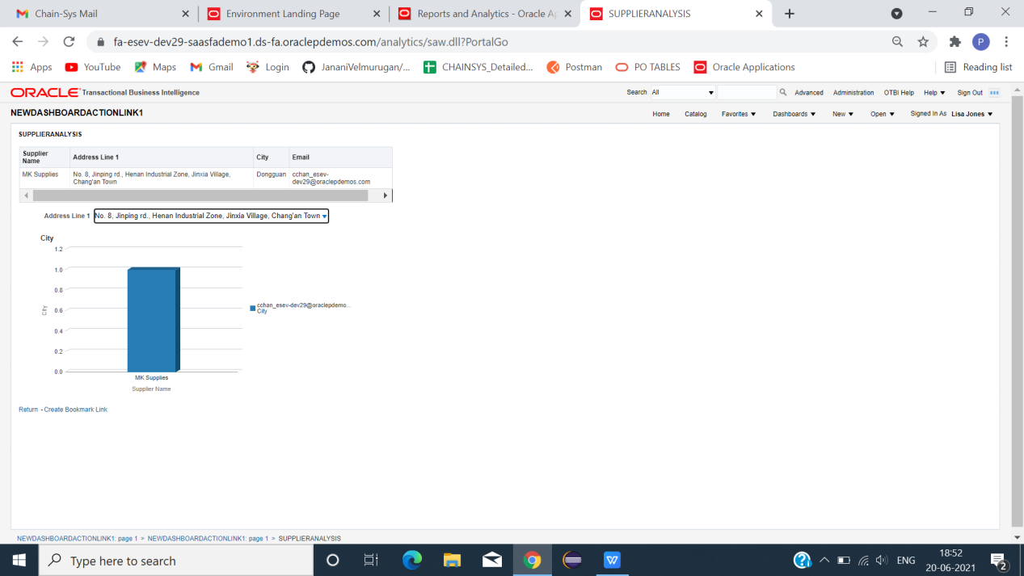

*ACTION LINK SUCCESSFULLY CREATED.